Homework Module 2 Mage:
Diagram:
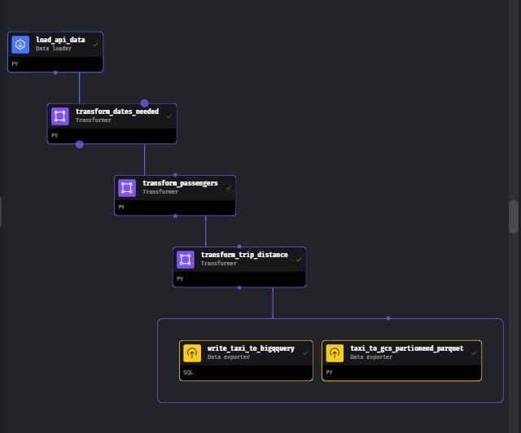
Code load_api_data
import io
import pandas as pd
import requests
if 'data_loader' not in globals():
from mage_ai.data_preparation.decorators import data_loader
if 'test' not in globals():
from mage_ai.data_preparation.decorators import test

@data_loader
def load_data_from_api(*args, **kwargs):

urls = ['https://github.com/DataTalksClub/nyc-tlc-data/releases/download/green/green_tripdata_2020-10.csv.gz', 'https://github.com/DataTalksClub/nyc-tlc-data/releases/download/green/green_tripdata_2020-11.csv.gz','https://github.com/DataTalksClub/nyc-tlc-data/releases/download/green/green_tripdata_2020-12.csv.gz']

taxi_dtypes = {
'VendorID': pd.Int64Dtype(),
'passenger_count': pd.Int64Dtype(),
'trip_distance': float,
'RatecodeID': pd.Int64Dtype(),
'store_and_fwd_flag': str,
'PULocationID': pd.Int64Dtype(),
'DOLocationID': pd.Int64Dtype(),
'payment_type': pd.Int64Dtype(),
'fare_amount': float,
'extra': float,
'mta_tax': float,
'tip_amount': float,
'tolls_amount': float,
'improvement_surcharge': float,
'total_amount': float,
'congestion_surcharge': float
}

parse_dates = ['lpep_pickup_datetime', 'lpep_dropoff_datetime']

dfs = [pd.read_csv(url, sep=",", compression="gzip", dtype=taxi_dtypes,parse_dates=parse_dates) for url in urls]

data = pd.concat(dfs, ignore_index=True)

return data

@test
def test_output(output, *args) -> None:
"""
Template code for testing the output of the block.
"""
assert output is not None, 'The output is undefined'

code transform_datas_needed:
import pandas as pd

if 'transformer' not in globals():
from mage_ai.data_preparation.decorators import transformer
if 'test' not in globals():
from mage_ai.data_preparation.decorators import test

@transformer
def transform(data, *args, **kwargs):

data['lpep_pickup_date'] = pd.to_datetime(data['lpep_pickup_datetime']).dt.date
#data['monat'] = data['lpep_pickup_datetime'].dt.month
data['monats'] = pd.to_datetime(data['lpep_pickup_datetime']).dt.month

print("Rows im Oktober:",data['monats'].isin([1]).sum())
print("Rows im Oktober:",data['monats'].isin([2]).sum())
print("Rows im Oktober:",data['monats'].isin([3]).sum())
print("Rows im Oktober:",data['monats'].isin([4]).sum())
print("Rows im Oktober:",data['monats'].isin([5]).sum())
print("Rows im Oktober:",data['monats'].isin([6]).sum())
print("Rows im Oktober:",data['monats'].isin([7]).sum())
print("Rows im Oktober:",data['monats'].isin([8]).sum())
print("Rows im Oktober:",data['monats'].isin([9]).sum())
print("Rows im Oktober:",data['monats'].isin([10]).sum())
print("Rows im Oktober:",data['monats'].isin([11]).sum())
print("Rows im Oktober:",data['monats'].isin([12]).sum())

print(data['monats'].unique())
return data[data['monats']>=10]

@test
def test_output(output, *args) -> None:
"""
Template code for testing the output of the block.
"""
assert output is not None, 'The output is undefined'

code transform_passengers
if 'transformer' not in globals():
from mage_ai.data_preparation.decorators import transformer
if 'test' not in globals():
from mage_ai.data_preparation.decorators import test

@transformer
def transform(data, *args, **kwargs):
# Specify your transformation logic here
print("Rows with 0 Passengers:",data['passenger_count'].isin([0]).sum())

return data[data['passenger_count']>0]

@test
def test_output(output, *args) -> None:
"""
Template code for testing the output of the block.
"""
assert output is not None, 'The output is undefined'

code transform_trip_distance
if 'transformer' not in globals():
from mage_ai.data_preparation.decorators import transformer
if 'test' not in globals():
from mage_ai.data_preparation.decorators import test

@transformer
def transform(data, *args, **kwargs):

print(data['VendorID'].unique())
print("Rows with 0 Trip Distance:",data['trip_distance'].isin([0]).sum())

return data[data['trip_distance']>0]

@test
def test_output(output, *args) -> None:
"""
Template code for testing the output of the block.
"""
assert output is not None, 'The output is undefined'

code taxi_to_gcp_partionend
import pyarrow as pa
import pyarrow.parquet as pq
import os

if 'data_exporter' not in globals():
from mage_ai.data_preparation.decorators import data_exporter

os.environ['GOOGLE_APPLICATION_CREDENTIALS'] ="/home/src/tobi-mage.json"

bucket_name = 'mage-zoomcamp-tobi-wissen'
project_id = 'tobi-mage-zoom-321'
table_name = "nyc_green_taxi_data"
root_path = f'{bucket_name}/{table_name}'

@data_exporter
def export_data(data, *args, **kwargs):
data['lpep_pickup_date'] = data['lpep_pickup_datetime'].dt.date

table = pa.Table.from_pandas(data)
gcs = pa.fs.GcsFileSystem()

pq.write_to_dataset(
table,
root_path=root_path,
partition_cols = ['lpep_pickup_date'],
filesystem = gcs
)

code write_taxi_to_bigquery
Select * from {{df_1}}

